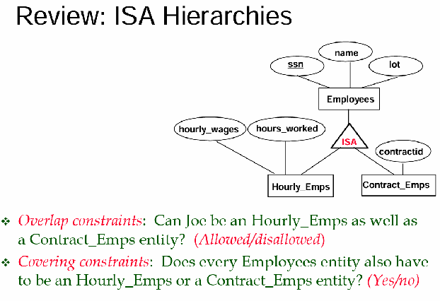

How to map ISA relationships?
ISA: employee entity set with ssn as primary key. We have also as subfamilies the hourly employees (with two additional attributes) and also we have contract employees (get the monthly salary).

We have the set of all employees and two subsets. By default we say that there is no overlap between hourly and contract employees. Also there can be employees that are nor hourly employees nor contract employees.

ISA relationship - op.1 with overlap and no cover
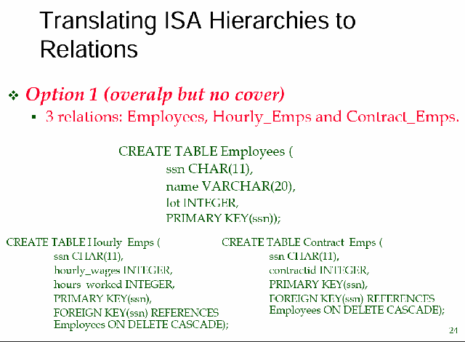
One option is to use three relations (one for each entity set, one for the superclass [employees], and the two subclass hourly and contract employees)

All hourly employees must inherit the ssn of the employees class. So the primary of hourly employees will have as primary key the ssn of the employee class. No need to repeat the name and parking lot (lot) of the employee, to avoid redundancy, those attributes can be obtained by the employee class.

But we need to add the special attributes specific for the hourly employees entity set.

Same thing for the contract employee entity set.

Can have:
- An employee that is both hourly and both contract employee at the same time
- An employee that is only hourly
- An employee that is only contract
- An employee that is neither hourly nor contract

Use ON DELETE CASCADE to be sure that once an employee is removed from the employee entity set then it is removed also in other subclasses where he appears. When we delete from the master table it should be deleted everywhere

ISA relationship - op.2 no overlap and cover/no cover
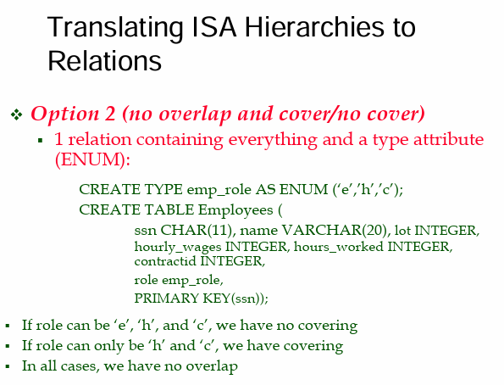

Just one table called employees where we put all the employees.
e = employees
h = hourly employees
c = contract employees

We need an attribute that can be an integer or letter as a flag that represents a category of the employees. We use AS ENUM and we write the only value that an employee can have (e, h, c). And the primary key must be the ssn

If I want only hourly and contract employees we can just remove the ‘e’ and leave h and c. So we can support both cover or no cover.

However we can not support overlap, if an employee must have one table for the ENUM it can not only be one thing at a time. We could add combination of employees to represent other possibilities (but it is exponential).

ISA relationship - op.3 overlap and cover
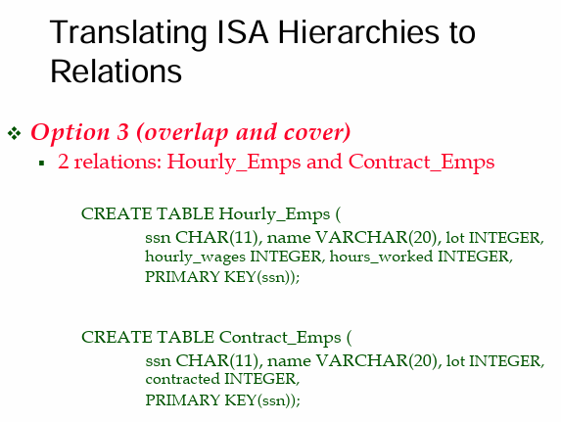

Use only tables for the children. We do not have master table but only the hourly employee and the contract employee.

In both we have ssn, name and parking lot.

Advantages:
- We can encode cover and overlap together

Disadvantages:
- We can not find all the employees together (because there is no master class)
- There can be multiple ssn, you break the unique key
Avoid this approach as most as possible

NOTE: with op.1 we can connect all the employee sets or just the hourly or the contract employee to another entity set. But this is not possible with op.2 and op.3 can not connect employees in general (aka hourly and contract employees) to another entity set.

NOTE: option 1 is the best one but can only implement overlap with no cover, but we could enforce the cover constraint later

Aggregation
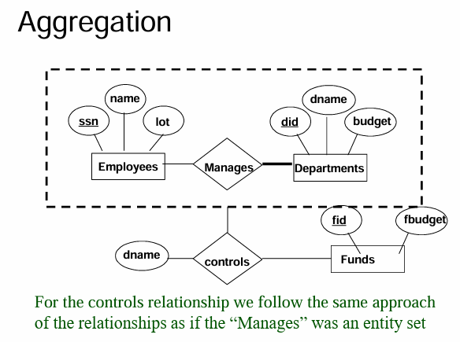

How do we map aggregation?

Aggregation: to use a relationship as an entity set in relation to something else. We transform temporally a relationship to an entity set.

A department is managed by at least one employee. And when an employee manages a department it controls and has a certain budget.

